Competition Management
Competition > Competition Management > Setup Wizard
We recommend following the steps outlined in the Competition Setup Wizard in order to complete your setup. You can come back to this page at any time to pick up where you left off. Alternatively, each of the steps can be found under the Competition tab in Competition Management mode.

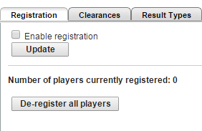
Step One: Review Competition Settings
Competition > Competition Settings
- Enable Registration - In order to use the Registration feature, it must be enabled here. Check the box and click Update to enable. If Registration in not enabled, clubs will not be able to register players to the association.

- Enable Clearances and Permits - If Clearances are not enabled, clubs will not be able to apply for Clearances with the association, however the clubs can still Transfer players

- Result Types - Result Types can be disabled within each Match Format (if match formats have been enabled). This will prevent the result type from being able to be selected when entering a match score.

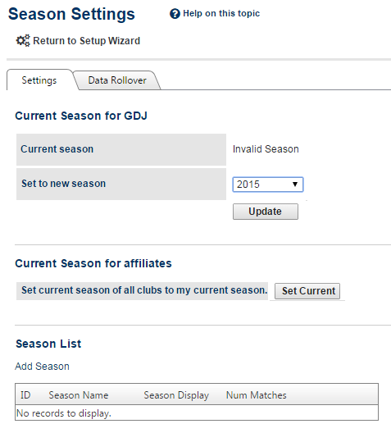
Step Two: Set/Rollover Season
Competition > Season Settings
- Set Current Season - This tab allows you to set the current season of your organisation and its child organisations. The current season is selected as a default in most pages (both admin and public) that have a season dropdown list within the selector bar. Before you can do other setup such as creating fixtures etc., you must set the current season.

- Season List – New seasons can be added in this screen by clicking the ‘Add Season’ list.

- Date Rollover – This process will copy the selected data from one season to another.
Step Three: Create Venues
Competition > Grades > Venues > Maintain Venues > Add New Venue
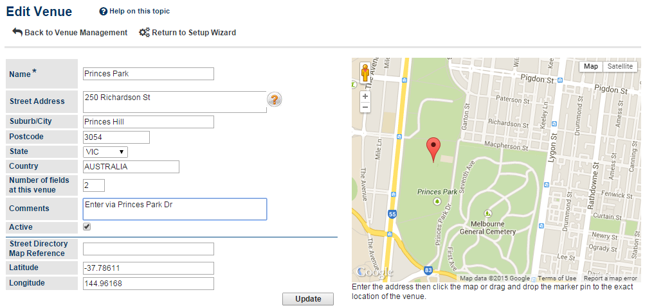
- Add New Venue – This page allows venue information to be maintained by an association.

Step Four: Configure Ladder Points Schemes
Competition > Ladders > Ladder Points Scheme > Add New Ladder Points Scheme
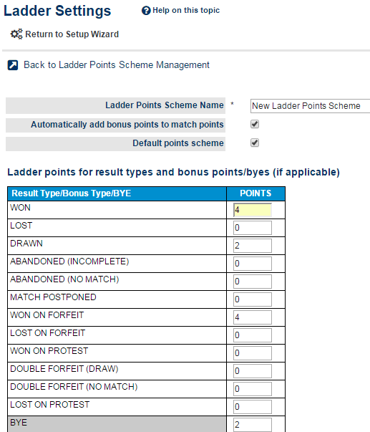
- Add New Ladder Points Schemes - This page allows Ladders Points Schemes to be set up and modified. Ladder points schemes define how the ladder points of automatically calculated ladders are determined. Schemes are defined by the organisation managing the competition, and can be reused across any number of grades and seasons.

Step Five: Configure Ladder Display Scheme
Competition > Ladders > Ladder Display Schemes
- Add New Ladder Display Scheme - This page allows Ladders Display Schemes to be set up and modified. Ladder Display schemes are a collection of settings that control various display properties of ladders as they appear on public web site
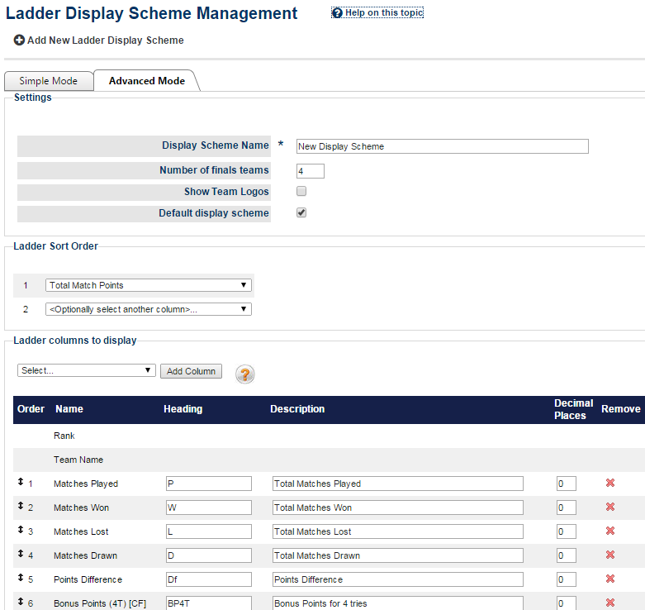

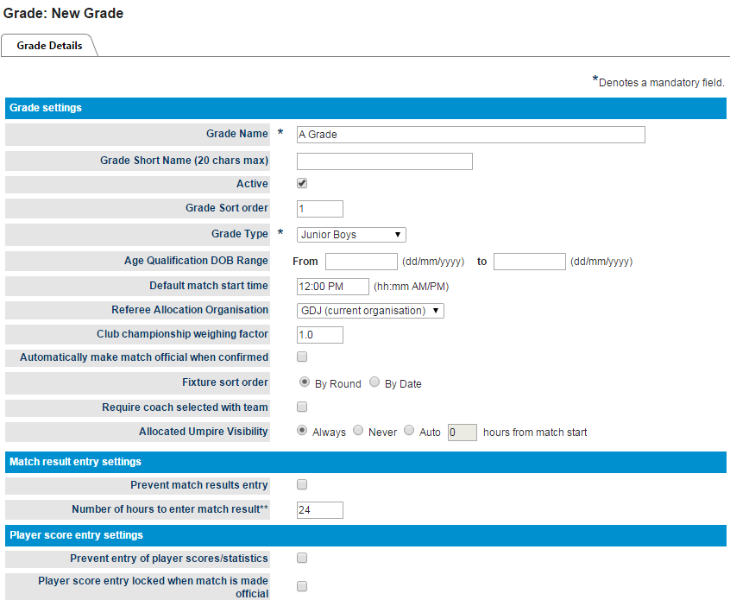
Step Five: Manage Grades
Competition > Grades > Maintain Grades, Teams and Ladders > Add New Grade
- Add New Grade - This page allows grade information and options to be entered and modified. Settings on this page affect the grade across all seasons.

Step Six: Allocate Teams to Grade
Competition > Grades > Maintain Grades, Teams and Ladders > Allocate Teams Tab
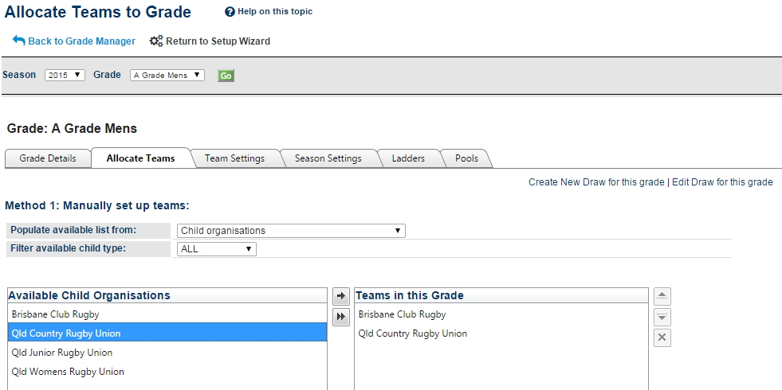
- Allocate Teams to Grades - This screen allows teams to be allocated to a particular grade for a particular season (i.e. which teams participate within the grade).

Step Seven: Assign Ladders
Competition > Grades > Maintain Grades, Teams and Ladders > Ladders Tab
- Add New Ladder - This page allows ladders to be set up and modified within a grade and season. Summary of ladder features:
  - Any number of ladders can be set up for a particular grade and season.
  - Each ladder can include all matches, or optionally filter the matches by one or more match formats.
  - Ladders can each have completely different settings, however must all share the same ladder points scheme.

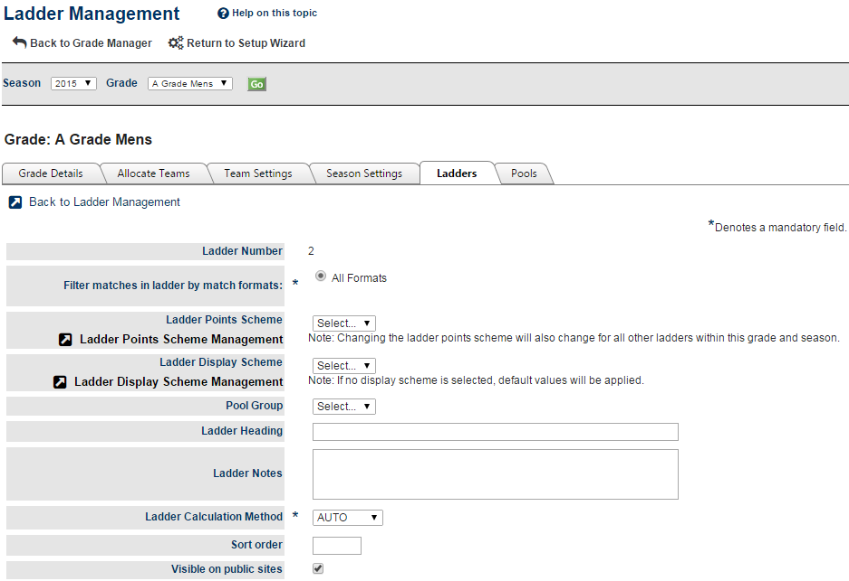

Step Eight: Create Draw
- Enter Draw Information
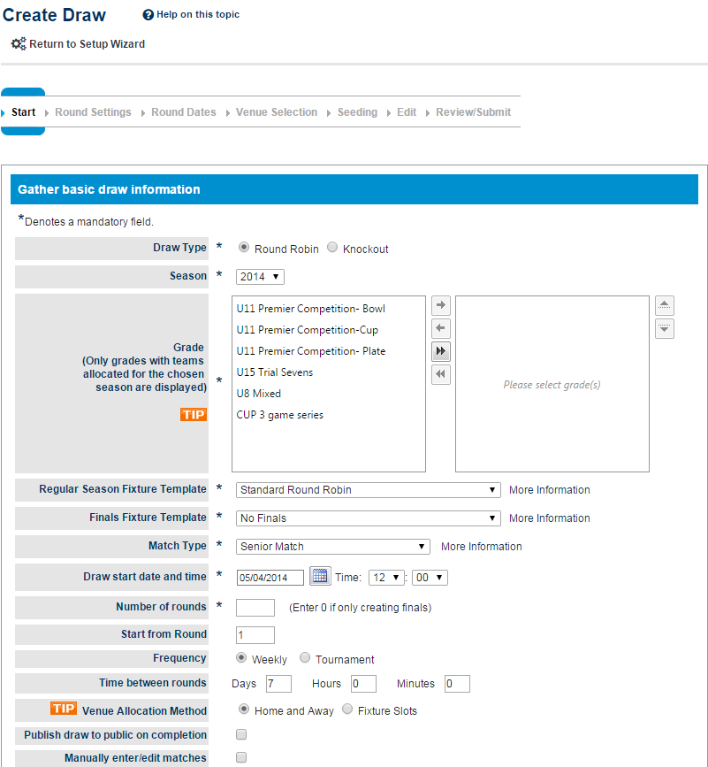

- Venue Allocation Method:
Home and Away – Venues and start times are allocated according to the settings for the Home Team in the TEAM settings tab under Grade Management. Typically, this is for club based competitions that may alternate venues.
- Fixture Slots – Venues and start times are allocated according to the fixture slots as defined for this grade and season. To create fixture slots users will need to head to Competition > Draws > Configure Start Times. Typically, this is for competitions run out of a select number of venues.

- Manage Date Ranges - The non-playing date groupings page allows for the organisation of multiple date range's under a single heading. (eg: School Holidays).

- Set Round Dates and Times - The Draw Creator calculates the dates for each round of matches according to the settings entered in the first two pages. This page allows those dates to be changed.
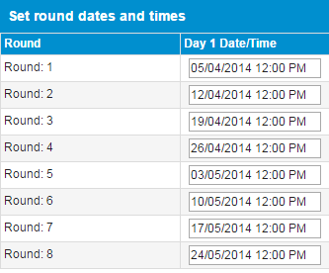

- Venue Selection - This screen allows for settings relevant to the "Fixture Slot" Venue Allocation mode and is not displayed if the "Home and Away" mode is selected.
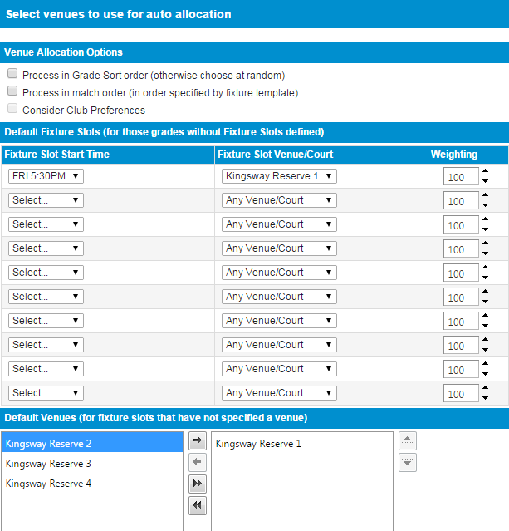

- Set Team Seeding Numbers - Draw team seedings will determine which teams play each other in a given round over the entire draw. These can also be setup in the Team Settings page but a random seed will be set for all those teams that do not have one set before this page is displayed.

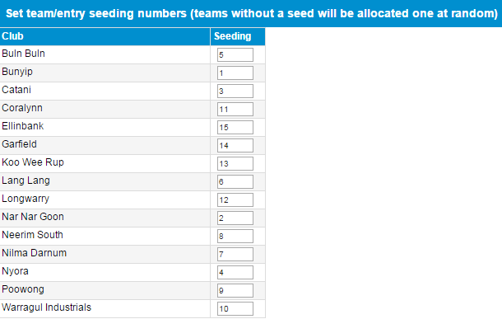

- Final Review & Submission – If during the review you need to go back and change information in previous pages you can click the heading of the page in the wizard progress display header or click the Previous button.

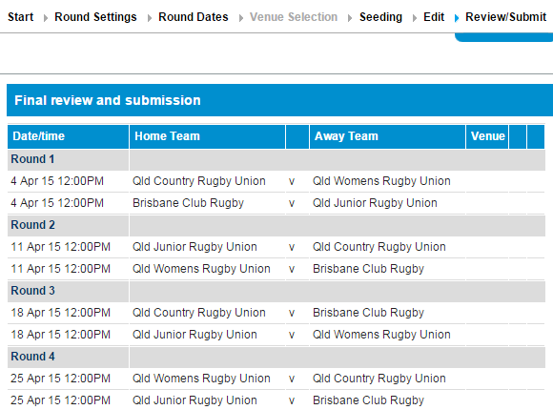

Step Nine – Publish Draw
Competition > Draws > Draw Management > Publish Tick Box
This screen allows draws to be bulk published or unpublished. An unpublished draw is not available to the general public
