March 2016

Participant Logins

Participant Help Guide

Existing Participants – No Active Account
Creating Accounts
Existing participants without an active account are able to create their own login via the Login screen found in the public portal.
Participants who do not exist will need to be entered into the system by an administrator prior to creating an account.
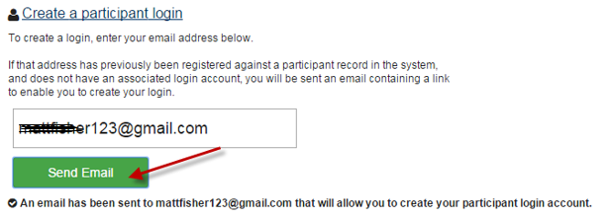
The participant is sent a link to create their account using their email as the login ID.
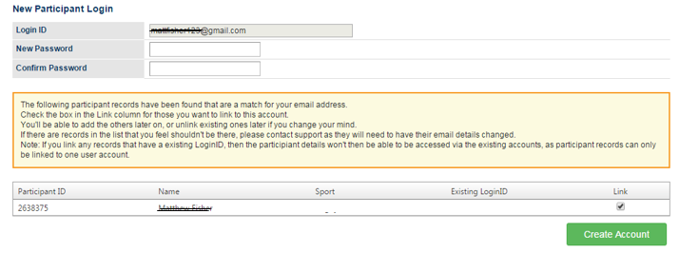Note: Other participants with the same email address attached to their record will be listed here. The participant has the option of linking these accounts under the single login ID, which also creates the account for the other participants. This is particularly useful for linking family members under the single login ID.
Once the account is created, the participant (and any linked accounts) can now login using the email and chosen password.

Existing Participants – Numeric Login ID
There was no major change to these types of logins, participants can continue using their numeric ID but cannot link other participant records unless they are upgraded to use an email address instead.
Upgrading to Email Login
The ability to use an email login ID is widespread across the internet and removes the hassle of trying to remember (sometimes multiple) numeric ID’s.
To switch to an email login ID, login using the existing numeric login ID and password. If these details are unknown, complete a password reset by clicking the ‘Forgotten password or login details link’ on the login page.
Once logged in, click on the name in the top right of the screen and then ‘change your login account details’.
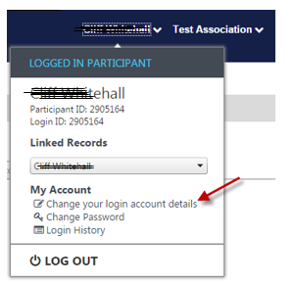

The participant will then see a link to ‘Click here to convert your Login ID to use your email address’ and asked to generate an email confirming the email address is owned by the participant and is valid.

Once the validation takes place, the login will be converted and the participant can immediately use their existing password and email to login.

Linking Accounts
If other participant’s exist and have the same email address as an existing email login participant account, these accounts can be linked under the single login ID. The linking of accounts is optional and allows for an easier login process and the ability to seamlessly switch between accounts. Accounts can also be unlinked at any time.
To link accounts, click the participant name in the top right corner and select ‘Link or Unlink records’
Note: Linking accounts via this method is independent of any ‘Family Relationships’ that exist. Linking participant accounts does not create or effect existing Family Relationships in any way.

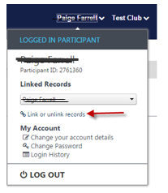
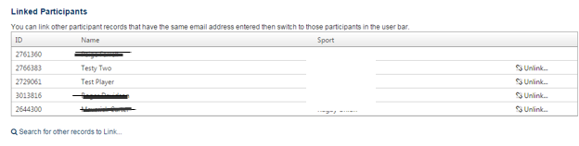
A list of participants using the same email address will appear and will be available to link.
Once accounts are linked, easily switch between participants.
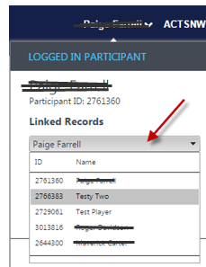
The default account that is displayed will be the last record that was selected upon logging out.

Note: Account linking is not restricted to a single sport database. Any participant using the same email address as the logged in participant across the entire system can be found and linked.

Unlinking Accounts
To successfully unlink a participant, the first step is to edit the Participant Profile of the person being unlinked.
Select the profile of the participant who is being unlinked and select ‘Change your details’
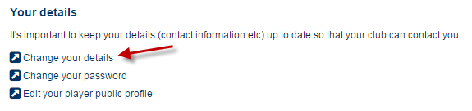
Change the email of the participant to an address that is unique to the system.
Return to an alternate participant on the account and select ‘Link or Unlink’ records. Unlink the desired account to remove the account from being accessed via this email login.
The unlinked participant can now create a participant login via the login screen or by contacting an administrator.

Online Registration – Return User
When logging in with a linked account via an online registration form, the participant will be given the option to select which of the linked participants they wish to register.
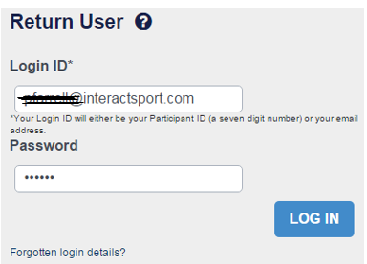
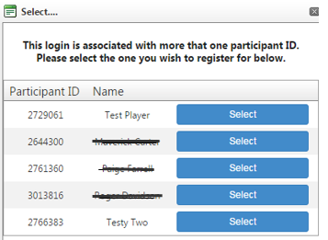

Online Registration – First Time Participant
If a new participant creates an account during the registration process and uses an email address that is already being used as a participant login, these accounts will automatically be linked. If the participant’s email is not already in use as a login ID, an email invitation will be sent to create a login account

Senior Player Registration - Test Club - Submitted
Thank you Kelly!
You have successfully registered for Test Club 1
Your Participant ID is: 3017879
A confirmation email has been sent to pfarrell@interactsport.com
There is already a participant login account for the email address: pfarrell@interactsport.com. This new participant record has been linked to the login account.

