Player Transfers, Clearances & Permits
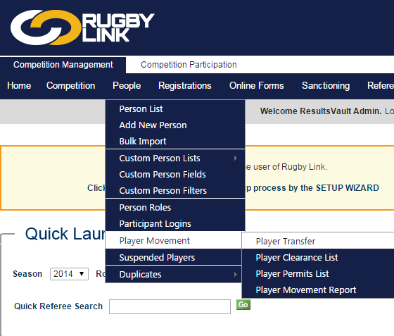

Player Transfers
Nav: People > Player Movement > Player Transfer
Person Transfer involves adding an existing person's record to one or more other organisations - which means that only one set of information (name, contact details etc.) is maintained for that person. This is the preferred method for moving person records between organisations, as it results in no duplication of information.
Transferring a person does not alter the Roles held by the person within other organisations. It is up to those organisations to remove roles as appropriate. For example if a person is a PLAYER at Club A, and wishes to play at Club B, Club B would initiate the transfer. This adds a PLAYER role for the person at Club B. If the person is no longer playing at Club A, Club A should remove the PLAYER role from the person record.
Important Notes:
- Before transferring a person record, please ensure that you are aware of any other requirements (such as Player Clearance requirements) that may apply. The onus is on the organisation initiating the transfer to ensure the record should be transferred. For example, if you are from a club and are not sure whether a player requires a clearance, please do not transfer, and contact your association for further information.
- An email will be sent to the person advising of the transfer to ensure that he/she is aware of the transfer, and to provide for an opportunity to reverse the process.
- Emails will also be sent to other organisations where the person has a current role.
- An audit record will also be created within the system detailing the user that initiated the transfer.
Player Clearances
Nav: People > Player Movement > Apply for Player Clearance
Player clearances are used by clubs to gain approval from their governing body to transfer a player from one club to another. Throughout the process, the affected clubs and the association are notified by email as to the actions that are required at any stage.
- Search for the player or the player club
- A list of players is displayed. Click the Select link. Make sure that where a player is listed as belonging to more than one club, that the correct club is chosen.
- Select the season and the association the clearance applies to.
- Fill in the Clearance reason and optionally the To club comment
- Click Submit
- Note: When applying for a clearance for a player that is not in RugbyLink, first add that player to your player list and then apply for the clearance. A note should be added to the From Club Comment that the player was not within RugbyLink
Clearance Process
Club (destination club) applies
for a player clearance
The player's current club (also referred to as the 'from' or 'ex' club )
must grant or deny the request
The relevant association must grant or deny
the clearance request
Once clearance is granted the
player is automatically transferred
to the destination club
(this means that the player then appears on the active player list of the destination club)

Clearance Denied
If a club denies a clearance, the association can override and grant the clearance.
If more information is requested by any party, the request essentially goes back to the prior status. For example, if a club has 'granted' a clearance, then the association requests more information, that club needs to provide the information, and grant the clearance again.
All changes to the clearance application will result in an "audit" record that is accessible by the association. Personal details of a player being cleared from another club will be obscured from the applying club until that clearance is granted.

Player Permits
A player permit is a mechanism whereby clubs gain approval from their governing body for a player who may otherwise be prevented from playing, such as overseas players or professionals. Permits are generally a one-off or for short term purposes.
Note: Permits have a similar process to that described for Clearances, except the application is between one club and the association. A player must be on a club's player list before a Permit can be requested.

