Match Day Information Sheet
Sign On Sheets
Navigation: Tools > Team Lists
Sign on sheets (including player portraits) are able to be accessed and printed to record attendance prior to a match.
To add a Player Portrait: People > Person List > Double Click on a player > Player Tab > Profile > Upload Photo
Team lists can be generated for any round and grade of the current season. Columns can be hidden or displayed as required.
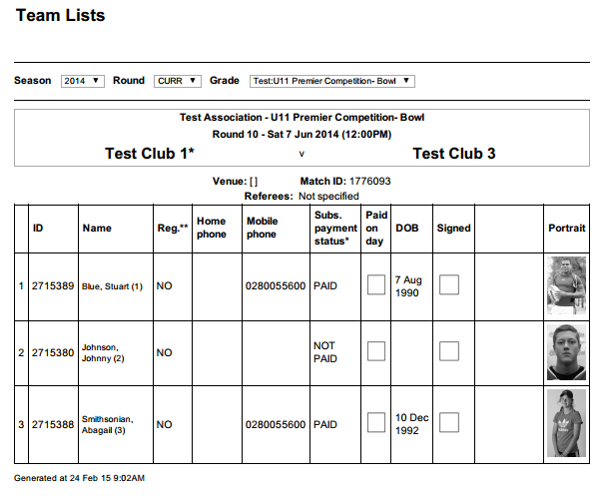

Team Sheets
Navigation: Tools > Match List > Select Match > Print Scorecard (from actions drop down box)
Team sheets contain individual player information such as statistics, position and shirt number. These can be printed and taken to a match to easily record match results, player scores and penalties.

Entering Match Results
Scenario 1: Club Enters Match Results
Navigation: Tasks > Enter Match Results
Once a match is completed, you can enter scores in the Match Result and Score Entry Screen. Rugby Link has a match entry and confirmation process whereby one team enters the match result, the opposing team confirms or disputes the result, and the association finalises the result, resolving any disputes in the process.
Scenario 2: Association Enters Match Results
Navigation: Tasks > Enter Player Scores/Incidents
If your association enters Match Results (number of tries and final score), the ability to enter results via the Enter Match Results screen becomes locked. Clubs will need to provide the remaining information (conversions, penalties, field goals etc.) via the Enter Player Score/Incidents screen.
Player incidents (Sin Bins and Send Offs) are also able to be added, confirmed and disputed here.
